DAL-BO COMPACT
830 + 930 cm

Congratulations on your new COMPACT. For safety reasons and in order to obtain the optimum use from the machine, you should read through the following instructions before putting the machine into operation.

© Copyright 2000, DAL-BO. All rights reserved.

Items which are essential from a safety point of view are preceded by a bold exclamation mark ∇.

∇ Tighten all nuts after a few hours' use.
∇ The hydraulic system must not be operated unless the roller is securely connected to a
tractor.
∇ The machine may be operated only when the driver is seated on the tractor, and there must
be no-one in the vicinity of the tractor or machine.
∇ The machine must not be operated by children.
∇ The driver is responsible for correct use of light and markings according to the present Traffic Act/ the Highway Code.

Your COMPACT has:
Serial number: . Type description: .
Month of manufacture: . Net weight kg: .

In the event of inquiries regarding spare parts or service, please always quote the serial number.
At the end you will find a list of parts which will help you when ordering and provides a clear
picture of the machine's components.

EU COMPLIANCE DECLARATION

Maskinfabriken DAL-BO A/S
DK-7183 Randbøl
hereby declares that the above machine has been manufactured in conformity with the provisions of the Council’s directive of 14 June 1989 regarding harmonisation of Member States’ machinery legislation (89/392/EEC), as amended on 20 June 1991 (91/368/EEC), with special reference to appendix 1 of the directive, concerning essential health and safety requirements for the design and
manufacture of machinery.

Maskinfabriken DAL-BO A/S

Kaj Pedersen, Director
TABLE OF CONTENTS:

Application: 3
Handling: 3
Fitting: 4
Start-up: 5
Operation: 6
Folding out: 6
“Duoflex” weight transference: 6
Folding up: 6
Maintenance: 7
REPAIRS: 8
Wheels: 8
Bearings, rings and shafts: 8
Rams: 12
Side sections: 15
Drawbar: 15
Scrapping: 15
ACCESSORY – 760 + 830cm 16
HYDRAULIC LEVELLING BAR 16
Application: 16
Assembly: 16
Adjustment: 17
Hydraulics: 17
Connection: 18
Testing: 18
Operation: 19
Maintenance: 19
Dismantling: 19
Scrapping: 19
HYDRAULIC CRACKERBOARD Fejl! Bogmærke er ikke defineret.
Mounting Fejl! Bogmærke er ikke defineret.
Driving and Operating Fejl! Bogmærke er ikke defineret.
Maintenance Fejl! Bogmærke er ikke defineret.
Repairs Fejl! Bogmærke er ikke defineret.
SPARE PARTS: 24

Application:
The Compact is used before and after sowing to break up clods and press down stones; it also improves germination. The Compact can be equipped
with a hydraulically controlled levelling bar, as an optional extra. It makes the
machine very effective on rough-ploughed land.

It is also used with advantage after stubble cultivation, to expedite the rotting
of straw and stubble remains and also the germination of waste- and weed-
seeds. For rolling very loose soil, it must be fitted with at least 50 cm rings.

The Compact is also used for rolling grasslands in the spring. This should be
done as soon as the land can be driven over. Rolling eliminates stones and
lumps of earth from the surface, so that they do not cause obstruction later
when the grass is mowed. At the same time, the Compact breaks up the
surface of the soil, allowing air to reach the roots.

∇ The Compact must not be used as a transport vehicle, pile driver, hydraulic
press or the like. If you are in any doubt, ask your dealer or DAL-BO.

∇ The Compact must not be used to roll areas of road or similar hard surfaces.

∇ When using the roller the operator must sit in the driver's seat on the tractor,
and there must be no other people either on or in the immediate vicinity of the
roller.

Noise:
The roller may make some noise when rolling with worn Cambridge rings, but
this will be far below the danger limit for tractor drivers.

Dust:
∇ A lot of dust can be raised during rolling under very dry conditions.
It is recommended that either the tractor doors and windows be closed or a
dust mask worn.

Handling:
For transport purposes, the roller is supplied in the following separate parts:

 | 830 cm | 930 cm
Middel section, cpl. | 1260 kg | 1570 kg
Right side section, cpl. | 1110 kg | 1270 kg
Left side section, cpl. | 1110 kg | 1270 kg
Drawbar incl. rams | 420 kg | 620 kg
2 wheels | 30 kg | 60 kg
∇ The parts will be handled with a crane. Hook onto the side sections in the
middle of the square pipe.
It must be fitted so that it tightens around the pipe during lifting.
∇ On the central section and drawbar yellow stickers showing a lifting hook
indicate where to hook onto for effective lifting.

Fitting:
Should be carried out in a workshop.
See Fig. 7 and 8.
A level floor, an approved crane cabable of lifting a minimum of 2000 kg and
a hydraulic pump with a single-acting and a double-acting take-off is required.
It must be able to exert a pressure of at least 170 bar.
Install the central section vertically on the roller rings and wheel hubs.
Fit the drawbar with the pin in position 26(830) – position 28(930), remember the split pin.
Fit the tilting ram, position 70(830) – position 71(930).
Fit and adjust the support so that the height of the drawbar is approx. 40 cm.
Connect the tilting ram to a single-acting hydraulic take-off; the hose is
marked white.
Lift one of the wheel hubs with the crane whilst carefully allowing the oil to
drain out of the ram
This will cause the central section to assume a horizontal position.
Lift each side section into position with the crane hooking onto it as described
under "handling". Secure the side sections with the pins, pos. 37(830) – pos. 40(930), which are in turn secured with the screws, pos. 38(830) – pos. 41(930).
Connect the hoses to the folding ram to a double-acting take-off.
Push the folding ram out almost to their full extent and fit, making sure that
the hoses do not cross.
Fit the wheels.
Apply pressure in order to push the folding ram all the way out.
Carefully rock the roller upwards by applying pressure on the single-acting
ram, making sure that all the hoses are able to move freely.
Carefully retract the roller with the double-acting valve, keeping an eye on the
hoses.
Ease the pressure on the single-acting ram so that the side sections drop down
into their transport bearing.
Secure the hoses to the folding ram with the hose clips and self-tapping
screws.

Fold the roller in and out a couple of times. Keep an eye on the hoses. The
folding rams are throttled op prevent too fast a movement. This is not of
crusial importance but it may give rise to a whistling sound in the pressure
valve on the hydraulic pump.
∇ Tighten all screws securely, including hub nuts.
The roller sections are swivelled back to the transport position in the reverse
order to extension.

Start-up:
Connect the roller to the drawbar of the tractor.
The drawbar must be original, intact and must turn properly.
The drawplate must fitted between the drawbar-plates. The drawplate can be replaced with a hitch hook if the tractor has one.
∇ Remember to secure the drawbar pin.

There are three attachment options if using an reverseible draw, as illustrated in the diagram below.

- High draw with drawplate mounted above. Dimension to lower surface approx. 65cm.

- High draw with drawplate mounted beneath. Dimension to
lower surface approx. 65cm.

- Low draw with drawplate mounted above. Dimension to
lover surface approx. 33cm.

∇ It is very important tht the drawbar is horisontal in the working position.

If the draw-point is too high will means, that the roller will not work with the inner parts of the side sektions, and the middel-sektion will be overload.
∇ Remember to secure the bolt connection thoroughly.
∇ Remember to secure the drawbar pin.

Tilting ram: One hydraulic hose (white) is connected to a single-acting valve and is used to tip the roller up onto its wheels, and down into its working position.
Folding in/out: The two hoses (red) are connected to a double-acting valve and are used to swing the side sections in and out between the roller’s transport and working positions.

All the hoses are fitted with 1/2” connectors. If the tractor is not equipped for
these, your dealer can help. A maximum pump pressure of 170 bar is required.
∇ Defective hoses must be repaired or replaced immediately. A broken hose can
in bad cases cause personal injury or mechanical damage to the roller.

Operation:
All operation must take place from the driver's seat and there must be no-one
else in the vicinity of the machine. The change from transport to operational
mode, and vice versa, must be made while stationary on more or less level
ground, with the tractor almost idling.

Folding out:
To unfold, operate first the singleacting valve (white), so that the side sections are lifted clear of their transport bearings; use the double-acting valve (red) to unfold the side sections completely.
Then lower the pressure from the single-acting valve (white), so that the roller tilts down to the ground. It is advantageous to to allow the valve (white) to float freely during rolling, if possible.
For undfolding and operating a Compact with Crackerboard notice the chapter “Hydraulic Crackerboard”

“Duoflex” weight transference:
Before rolling , it is nessasary to activate the double-acting valve (red) to float float freely.
The activate the double-action valve (red) until the manometer on the front of the roller shows 20-50 bar, depend on the type of soil. Then it is nessasary to allow the valve (red) to float freely, after which the hydraulic weight equalisation is activated.
∇ It is nessasary to adjust the pressure un proportion to the type of soil the roller is working in.

Folding up:
Before folding up, activate the double-acting valve (red) until the pressure on the manometer on the front has dropped to 0 bar.

Lift the roller completely vertical with the single-acting valve (white). Fold the side sections in by means of the double-acting valve (red). Lastly, lower them into their transport bearings using the single-acting valve (white).

The roller must be raised only for transport. It is not necessary to raise it when
turning. It can also run backwards in the operating position.
∇ Travelling speed not over 15 mph.

Recommended speed of travel: 4-5 mph. Move slowly over stony ground.

Maintenance:
Tighten all the screws, and also hub nuts, after the first working day.

Lubrication point | No. | Lubrication interval
Drawbar | 1 | 8 hrs.
Side sections | 2 | 8 hrs.
Folding rams | 4 | 8 hrs.
Tilt ram 830 cm | 2 | 8 hrs.
Tilt ram 930 cm | 4 | 8 hrs.
Wheel bearings | 2 | 1/season
Roller bearings | 6 | 50 hrs.

Adjust the wheel bearings once a year, following the instructions for replace-
ment of bearings, points 1, 2, 11, 12 and 13.

After the first season the surface of the rings will have worn smooth and they
will therefore take up slightly less space. Adjust the resulting clearance down
to max. 5 mm by moving the stop rings (see fig. 1). Remember to tighten the
stop ring screws well. It is advisable to slacken and retighten the screws a
couple of times so that they grip better.
Fig. 1:
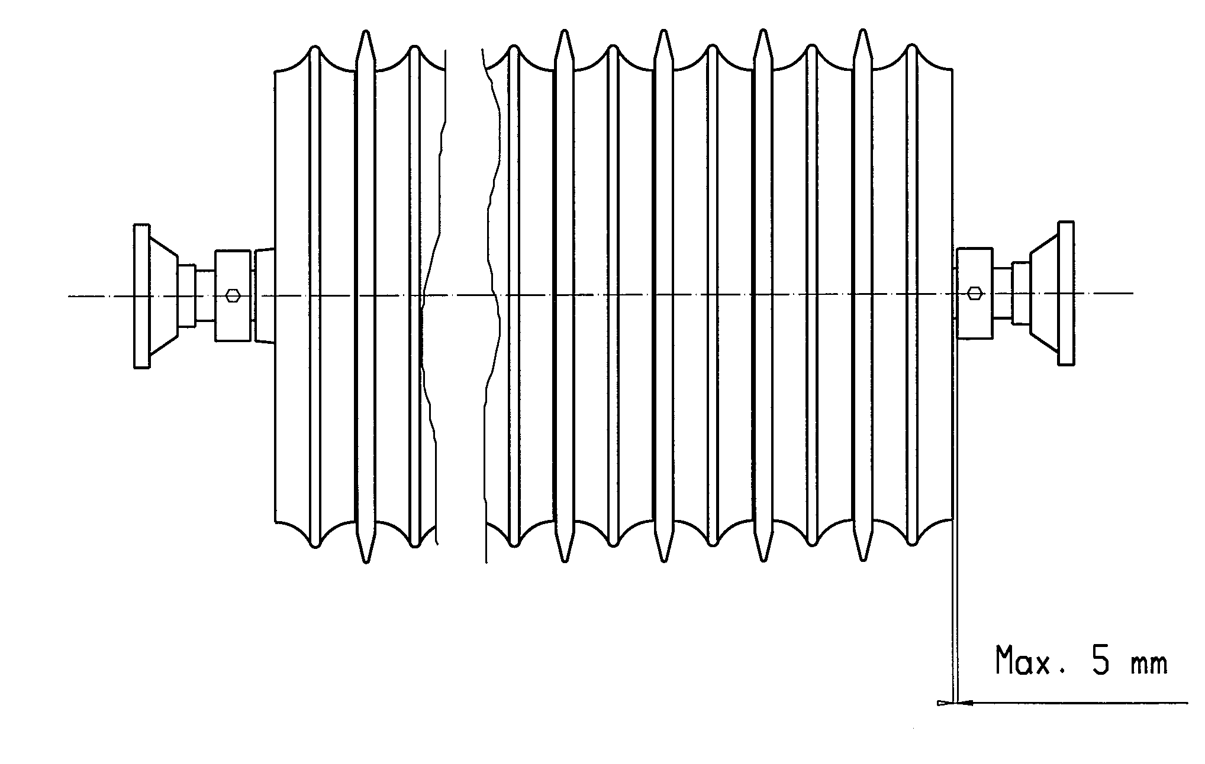

Check the air pressure in the tyres before the season.

Wheel Hjul | Ply | Air pressure
10.0/75x15.3 | 10 | 5.2 bar
10.0/75x15.3 | 14 | 5.5 bar
14.0/65x16 | 14 | 5.5 bar

∇ If the Compact is parked outdoors for a prolonged period, the piston rods should be lubricated using oil or pressure lubrication grease, to avoid rust damage on the piston rods.
Remember to remove it again before use.

REPAIRS:

Wheels:
For changing wheels owing to punctures, etc., set the machine in the operating
position. This enables the wheel to be removed without using a jack.

Changing the wheel bearings, see fig. 2.
1. Unscrew the hub cap, pos. 21.
2. Remove split pin pos. 20.
3. Remove lock nut, pos. 19.
4. The axle, pos. 2, can now be knocked out.
5. The bearings, pos. 17 and 18, can now be removed.
6. The sealing ring, pos. 16, can now be removed.
7. Install the outer races of the bearings, pos. 17 and 18, in the hub housing,
item 22.
8. Fit the sealing ring, pos. 16.
9. Mount the inner ring for the bearing, pos.17. on the axle, pos. 2, and
insert the axle in the hub housing.
10. Mount the inner ring for the bearing, pos. 17, on the axle, pos. 2.
11. Screw the lock nut onto the axle, pos. 2, whilst rotating the hub housing,
pos. 22. Tighten the lock nut so that it is difficult to rotate the hub
housing, pos. 22. Then slacken the lock nut until the hub housing can
again be rotated without resistance.
12. Fit the split pin, pos. 20.
13. Fit the hub cap, pos. 21.
14. Lubricate the hub with ball bearing grease.
Fig. 2:
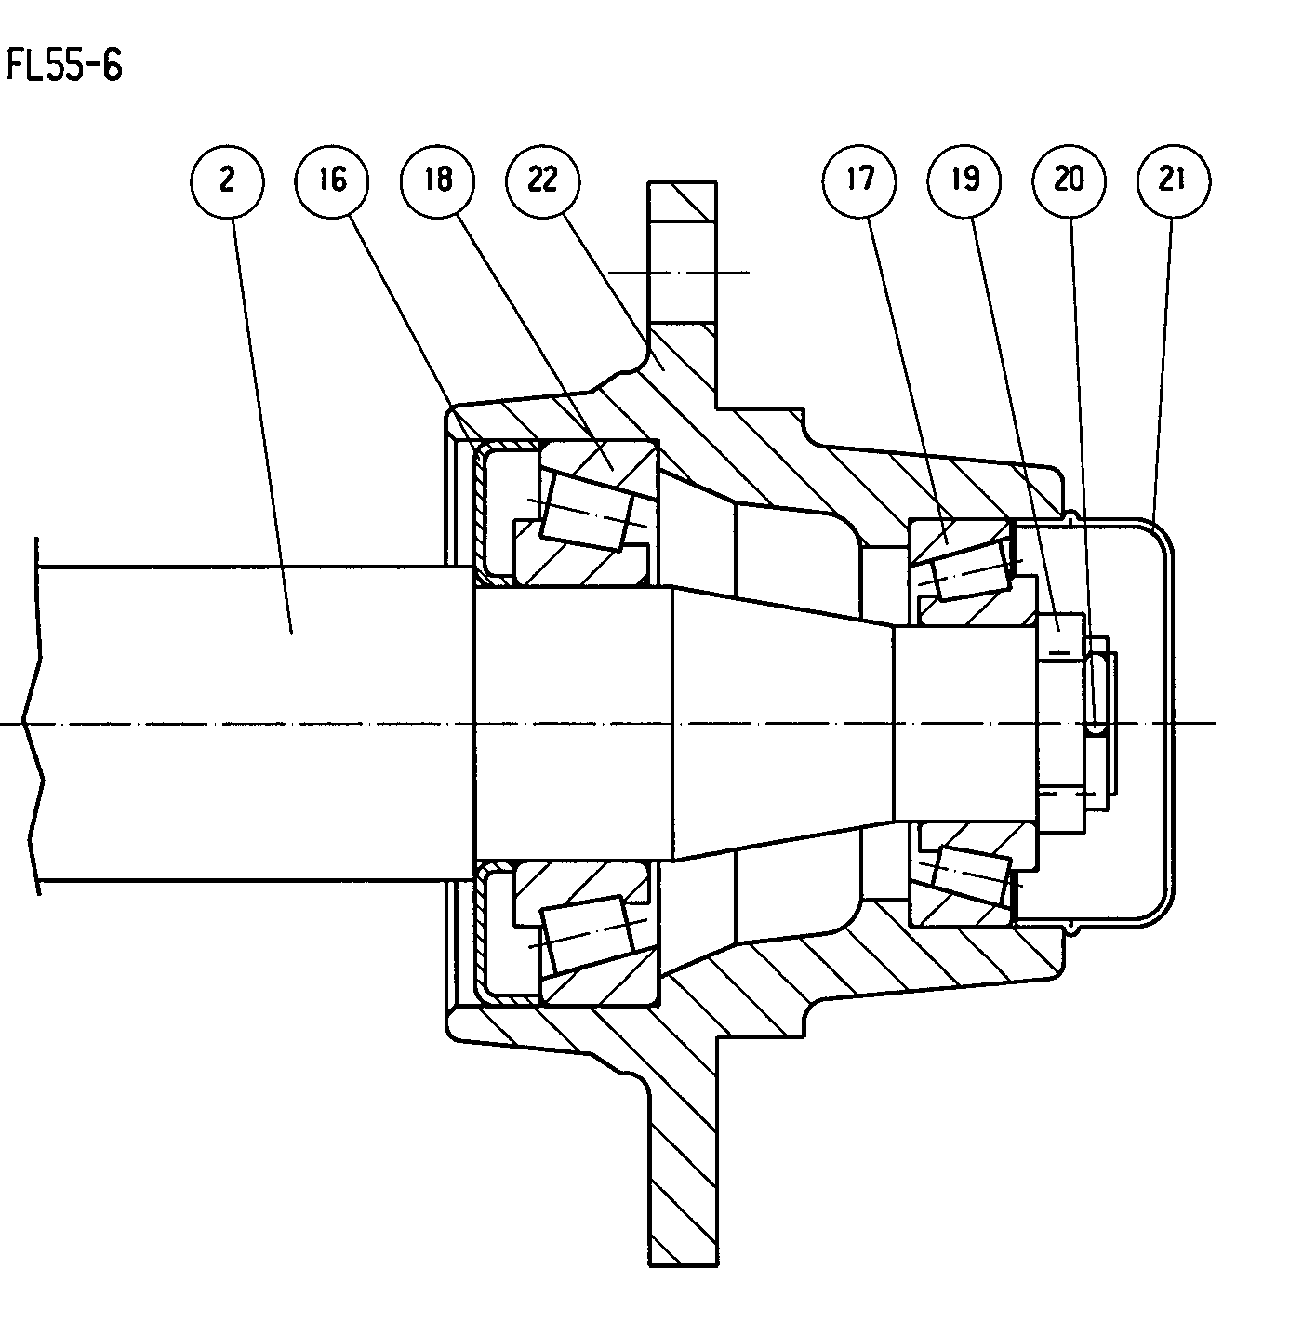

Bearings, rings and shafts:
Dismounting roller shaft with rings for replacement of bearings, rings or
shaft. This should be done in the workshop.

∇ Side section - DISMOUNTING:
For this, an approved crane capable of lifting at least 2000 kg is required.
The roller should be positioned with the appropriate section beneath the crane
- preferably coupled to a tractor, otherwise, a hydraulic pump with a single-
acting and a double-acting valve is needed. It must be able to deliver a
pressure of at least 170 bar. Connect the opposite section to the guide over the
transport bearing so that it can still be moved up and down. Using the single-
acting valve, lift the side sections clear of the transport bearing. Use the
double-acting valve to swing the side section concerned about 1 m out from
the side.

Start carefully with two chains/slings around the rings about 1 m apart. Lift
until the chains/slings are taut. Thoroughly loosen the bearing nuts. Lift with
the crane until the screws are loose. Remove them and the whole shaft can be
manoeuvred out.

Clear all grease from the bearing housings. Remove any burrs on the
protruding shaft end with a file. Loosen the pointed screws in the bearings; the bearings can then be pulled out.

When the stop ring with the two pointed screws has been removed, the
roller rings can be pulled off the shaft.

MOUNTING:
Cambridge rings. Start with a smooth ring with the “nose” pointing inwards
(see fig. 3). This is followed by a serrated ring with the smooth side facing
outwards. This must be pushed right over the boss (“nose”) of the smooth
ring. Fill the shaft up in this way until a space of about 12 cm remains. Omit
the last serrated ring. Ensure that the rings are packed tight together.
Fig. 3:

Crosskill rings. Note the direction of rotation of the shaft.
Start with a small ring, which must face the direction shown in fig. 4.
Then fit a bush, and a large ring above this, facing the direction shown in fig. 4. Finish with a small ring. Ensure that the rings fit tightly together.
Fig. 4:
Welled rings. Start with two rings, screwed together as shown in fig. 5.
Fill the shaft until a gap of about 22 cm is left. Close off the shaft with two
rings bolted together. Ensure that the rings are packed tightly together.
Fig. 5:

Insert the stop ring, fig. 3-5, pos.2, and tighten well. It is recommended
that the screws be tightened and loosened a few times to ensure that they grip
better.

Then insert the bearings on the shaft.

∇ Unfold the roller frame as described above. Attach two slings/chains to the
frame. Lift the complete shaft with rings, using an approved crane (min.
lifting capacity 800 kg) and lower it into the roller frame. The end with the
last mounted stop ring (fig. 3-5, pos. 2) must point inwards on the roller.

Fit the bearings and tighten. Remember to turn the lubrication nipples to
allow for lubrication (fig. 6). Use Locktite no. 270 on the pointed screws
and tighten well. Close up the roller as described under “Operation”.
Fig. 6:

Center section - DISMANTLING:
If possible, attach the roller to a tractor; if not, a hydraulic pump with a single-
acting and a double-acting valve will be required. The pump must be able to
deliver a pressure of at least 170 bar.
Use the single-acting valve to lift the side sections clear of the transport
bearings and use the double-acting valve to swing them right out.

∇ If the roller is not attached to a tractor, it must be opened up gently to
ensure that it does not tip over backwards.
Use the single-acting valve to lower the roller until the roller rings are resting
on the ground.

∇ The double-acting valve MUST NOT BE OPERATED in this situation.
∇ Secure the roller mechanically in this position, as a safeguard against the
possibility of hose rupture.

∇ The bolts holding the ball bearings can now be removed. Take care not to
injure your fingers.
Next, using the single-acting valve carefully tilt the roller upwards, ensure that
the roller shaft stays down on the ground.

ASSEMBLY:
Cambridge rings. Fit a stop ring about 12 cm in along the shaft (see fig. 3).
Then start with a smooth ring with the “nose” pointing outwards (see fig. 3),
and follow with a serrated ring with the smooth side facing inwards. This must be pushed right in on the boss (“nose”) of the smooth ring. Fill the shaft
up in this way until a space of about 12 cm is left. Omit the last serrated ring
and finish with a stop ring.
Crosskill rings. Fit a stop ring about 12 cm in along the shaft (see fig. 4).
Start with a small ring, then fit a bush, and a large ring above this, the spokes
of which run the same way as on the first ...... And so on, finishing with a
small ring and a stop ring.

Welled rings. Fit a stop ring about 12 cm into the shaft. Start with two rings,
screwed together as shown in fig. 5. Fill the shaft until a space of about 22 cm
is left. Close off the shaft with two rings bolted together and a stop ring.

Loosen the stop ring screws. The projecting shaft ends must be of equal
length. This is achieved by striking the shaft. Make sure that the rings are very
tightly packed. Tighten the stop rings well. It is recommended that the screws
be tightened and loosened a few times to ensure that they grip well.
Then push the bearings in along the shaft ends.

Open up the roller frame as described above under ‘Dismantling’. Push the
whole shaft into the frame. If it is a crosskill roller, ensure that the direction of
rotation is the same as shown in fig. 4. Mount the bearings and tighten securely. Remember to turn the grease nipples so as to allow for lubrication (fig. 6).

Raise the roller to the vertical position, using the single-acting valve.
∇ The DOUBLE-ACTING VALVE MUST NOT OPERATED until the
single-acting valve is fully extended.

Rams:
Folding ram:
This can be done with the roller in either the transport or the operating
position, where the ram is in both instances pressureless; but the operating
position is recommended.

Remove the hoses. It is recommended that a bucket be placed underneath to
catch any oil. Remove split pins and washers. The ram, weighing 21 kg,
can be dismounted also.

Assembly is done in reverse order. After assembly, carefully swing the side
sections out and in a couple of times (see under operation) to force out
unwanted air.
Check that the hoses can move sufficiently not to get jammed, and that the
connections are tight.

Replacing the hydraulic sealings:
REMOVAL:
1. Empty the oil from the ram, compressed air can be used to move the
piston rod back and forth, to press the oil out.
2. Place the piston rod in the middle position. Unscrew the gland (pos. 3) 30
mm out. If the gland can't be unscrewed, it may be necessary to warm it up
to 300°c. Let it cool off slowly. With the gland screwed out, pull the piston
rod out towards the gland. Screw the gland all the way off, and the piston
rod can now be removed.
3. Remove the sleeve (pos. 4).
4. Pull the gland off the piston rod (pos. 2).
5. The sealings above the sleeve are now removed, (pos. 5,6,7,8,9), use
either a awl or a screwdriver.
6. Clean all the parts. Check for filings and shavings, make sure that their is
no rust in the gland. If this is the case, it must be romoved.

ASSEMBLING:
1. Assembel the new sealings in the gland and sleeve. The scraper ring pos.
11 is mounted with the help of a pipe, that fits around the outside of the lip.
The sleeve (pos. 9) is mounted with a round iron bar or screwdriver
2. The threads on the gland and ram housing should be greesed before assem-
bling, (rust protection).
3. The gland pos. 3 is now mounted over the piston rod.
4. The sleeve pos. 4 is mounted and the self-locking nut pos. 1 is screwed on
with "loctite". Make sure that the threads are clean, no oil or greese.
With use of loctitte, you must not fill the ram with oil the first 12
hours.
5. Oil the sleeve and the top end of the ram housing, and press the pistion rod
into the middel position.
6. Screw the gland down tight.

Tilting ram:
This is done with the roller in the transport position. Remove the hose. It is
recommended that a bucket be placed underneath to catch any oil. Remove
split rings and pins, and the ram, weighing 41 kg, can be removed.

Assembly is done in the reverse order.
∇ There must be an air plug in the top connection. After assembly, lift the side
sections clear of the transport beaings a couple of times (see under operation).
Check that the oil connections are tight.

Replacing the hydraulic sealings:
REMOVAL:
1. Empty the oil from the ram, compressed air can be used to move the
piston rod back and forth, to press the oil out.
2. Place the piston rod in the middle position. Unscrew the gland (pos. 11) 30
mm out. If the gland can't be unscrewed,
it may be necessary to warm it up to 300°c. Let it cool off slowly. With
the gland screwed out, pull the piston rod out towards the gland. Screw the
gland all the way off, and the piston rod can now be removed.
3. Remove the sleeve (pos. 6).
4. Pull the gland off the piston rod (pos. 11).
5. The sealings above the sleeve are now removed, (pos. 5,7,9,10,12,13), use
either a awl or a screwdriver.
6. Clean all the parts. Check for filings and shavings, make sure that their is
no rust in the gland. If this is the case, it must be romoved.

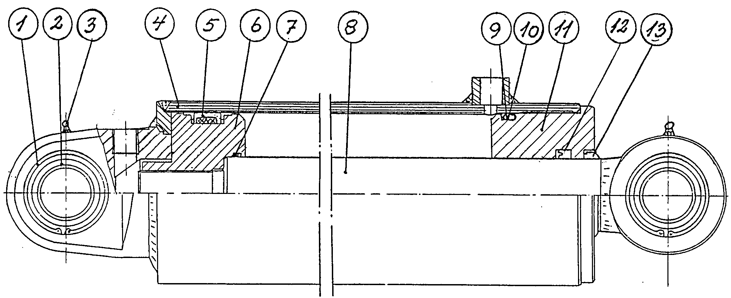

ASSEMBLING:
1. Assembel the new sealings in the gland and sleeve. The scraper ring pos.
10 is mounted with the help of a pipe, that fits around the outside of the lip.
The sleeve (pos. 3) is mounted with a round iron bar or screwdriver
2. The threads on the gland and ram housing should be greesed before assem-
bling, (rust protection).
3. The gland pos. 11 is now mounted over the piston rod.
4. The sleeve pos. 6 is mounted and locked in place with "loctite". Make sure
that the threads are clean, no oil or greese.
With use of loctitte, you must not fill the ram with oil the first 12
hours.
5. Oil the sleeve and the top end of the ram housing, and press the pistion rod
into the middel position.
6. Screw the gland down tight.

Side sections:
Removal of side sections should be done in the workshop.
First dismount the shaft with roller rings as described on page 5. Then support
the side section with slings on a crane (max. weight: 2000 kg). Unscrew the
two locking screws, and pull out the pin, using a crowbar or similar tool.
∇ Take care, when the pin has been removed, as the frame can then rotate.

Assemble in the reverse order.

Drawbar:
Changing the drawbar. This must be done in a workshop with a crane
available. Max. weight 1000 kg.
Place the roller on a level surface in the operating position without the tractor.
Lift the front end and remove the support leg. Lift just in front of the roller
main frame until the main pin is loose. Remove the ram; this can be done
without detaching the hose.

∇ Knock out or pull out the main pin. Take care and ensure that the drawbar
does not rotate.

Assemble in the reverse order.

Scrapping:
Dismantle the roller in the following sequence:
1. Side shaft with races, see page 8.
2. Middle shaft with races see page 11.
3. Side sections, see page 15.
4. Wheels, see page 8.
5. Drawbar, see page 15.
Send hydraulic hoses, oil and tyres to be destroyed.
Use the roller rings as recycled metal for casting and the rest for recycled
metal.

ACCESSORY – 760 + 830cm

HYDRAULIC LEVELLING BAR

Application:
Your Compact can be fitted with a hydraulic levelling bar in front of the
roller rings. This makes a very effective implement for breaking up clods and
levelling and packing the soil after ploughing.

Assembly:
Hitch the roller to a tractor and park it in the transport position on firm,
level ground. An approved lifting tackle must be available. Maximum
weight 250 kg.

See fig. 7.
Raise the bracket (position 1) for the central section under the drawbar and
secure it with the three clamp plates. Weight 65 kg. Tighten them only
slightly.
Bolt on and clamp the hydraulic unit (position 2).
Fig. 7:
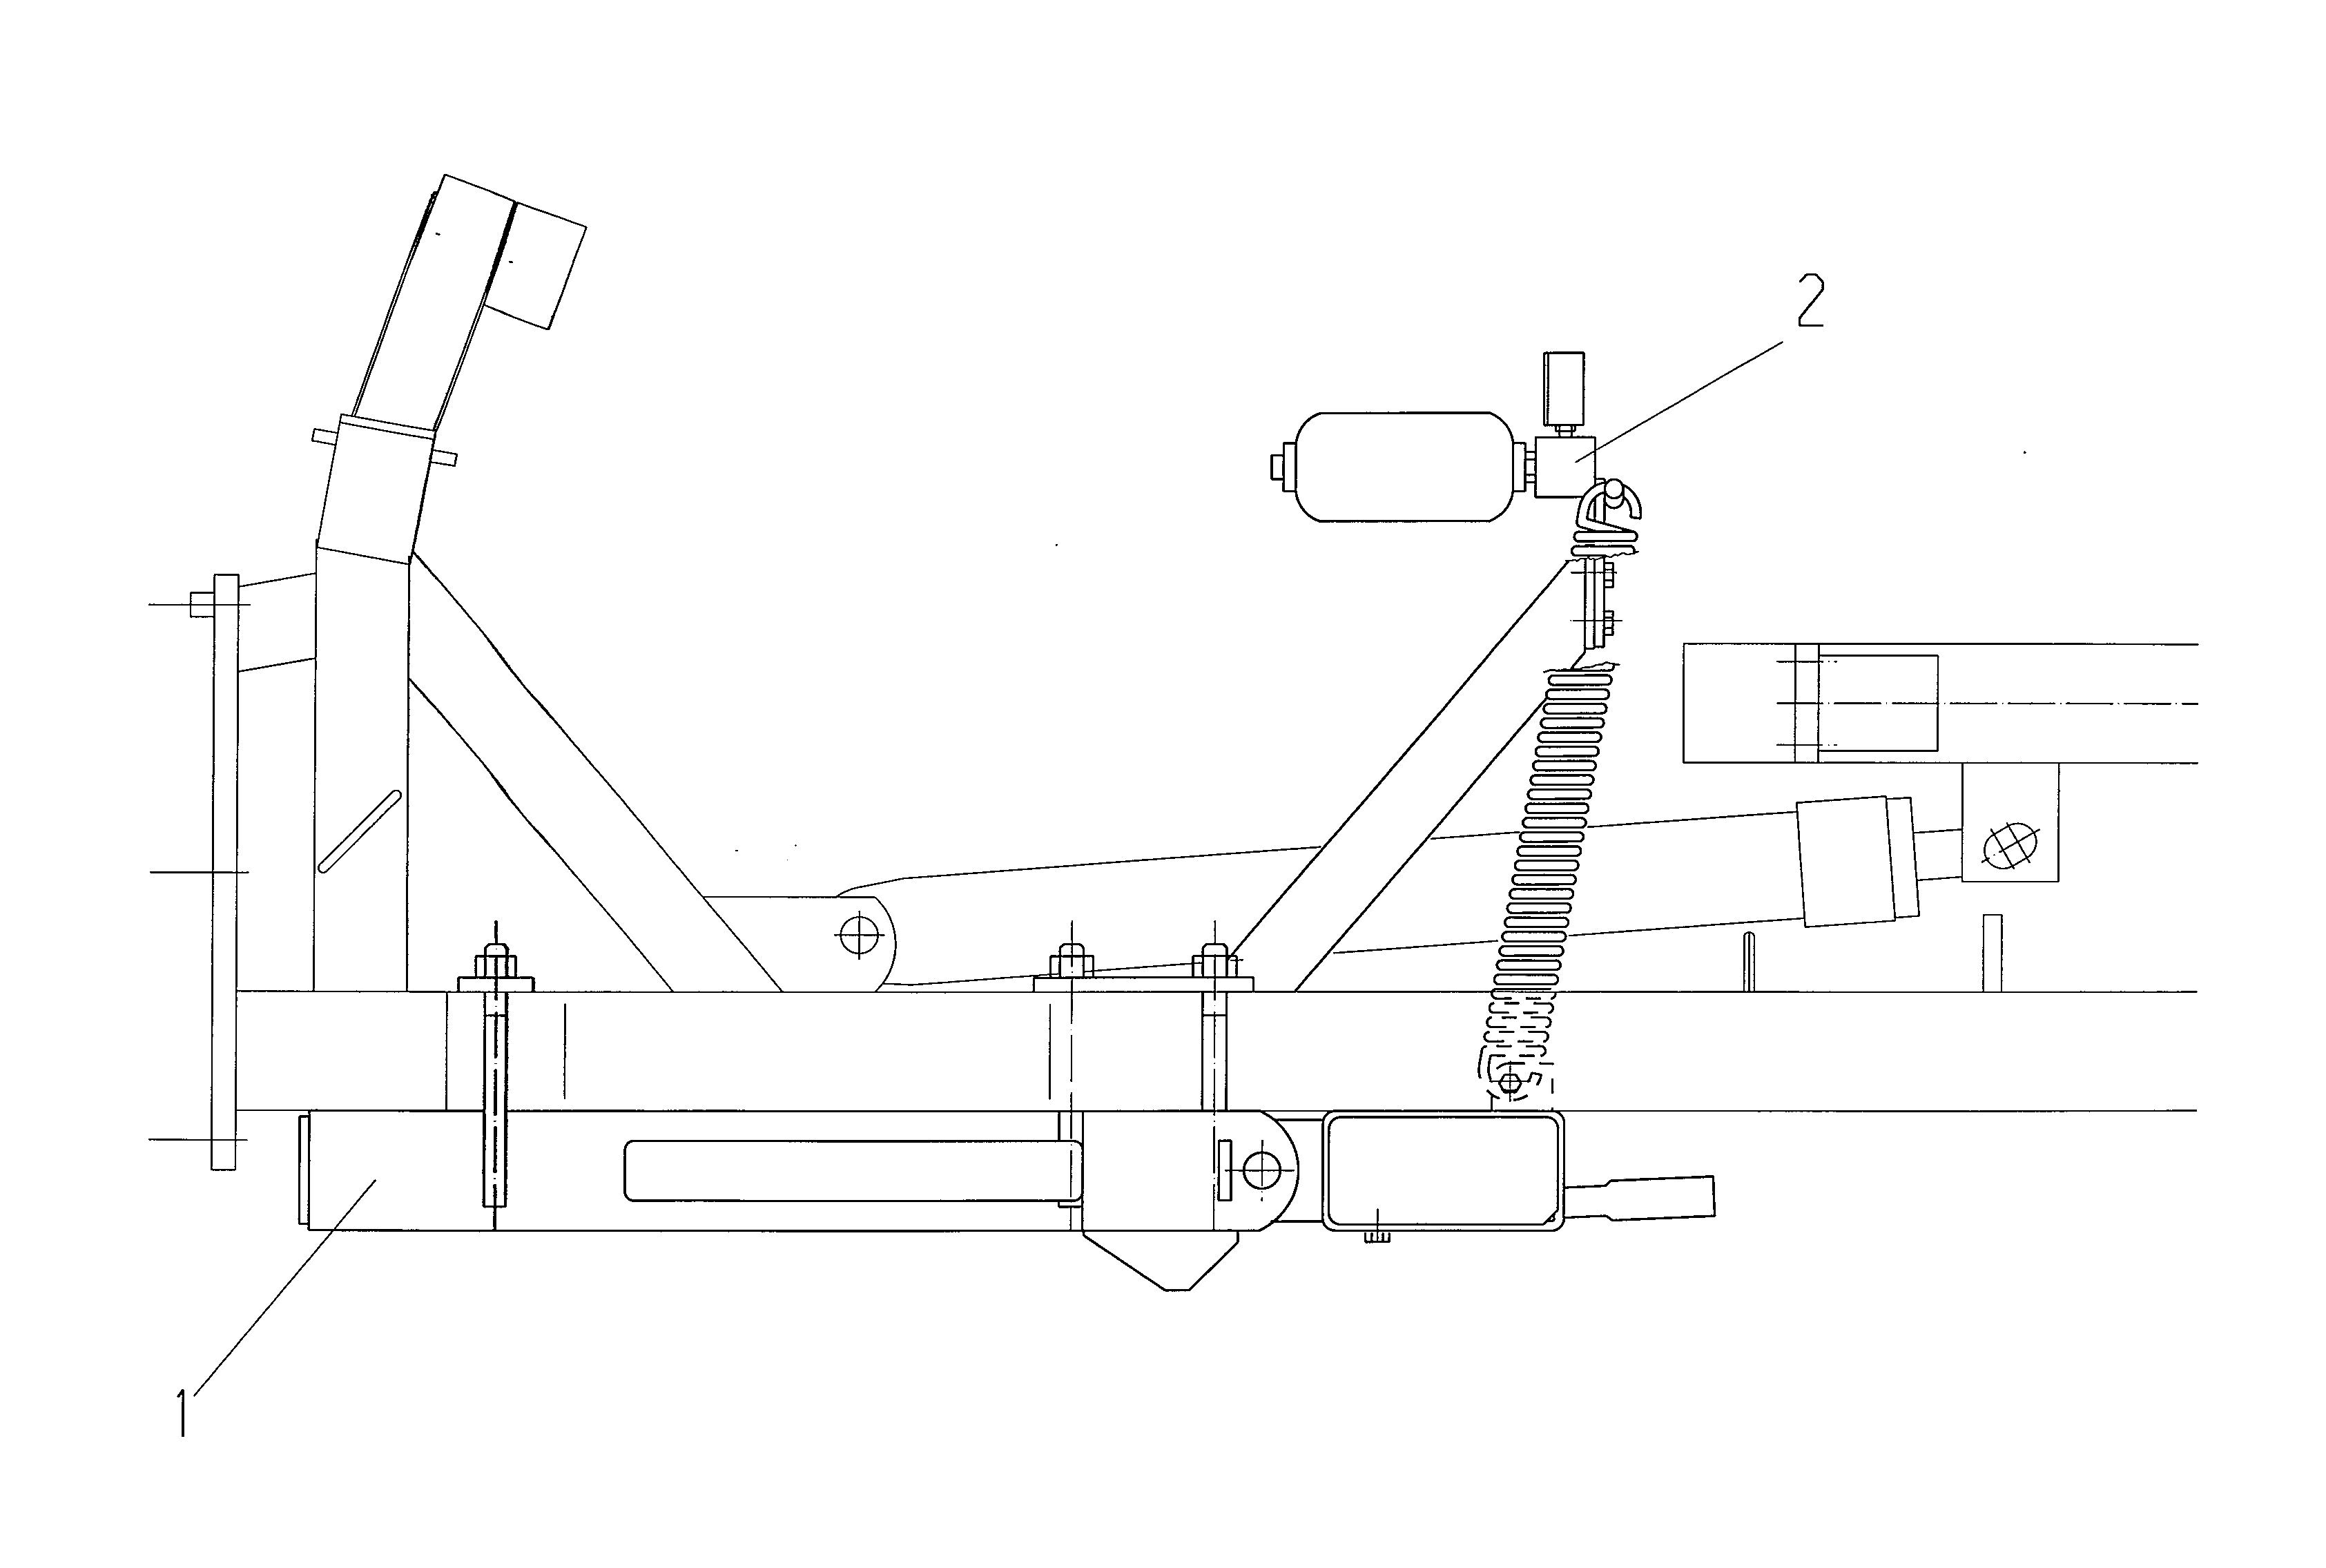
Open up the roller into the operating position (see above). Run it forwards
and backwards a few metres until the side sections are properly positioned.
Fit the innermost suspension for the side sections (weight 38 kg),then attach
the outermost suspension (weight 35 kg). Note the distance A between the
suspensions in fig. 8, (A=xxx cm).
Fig. 8:

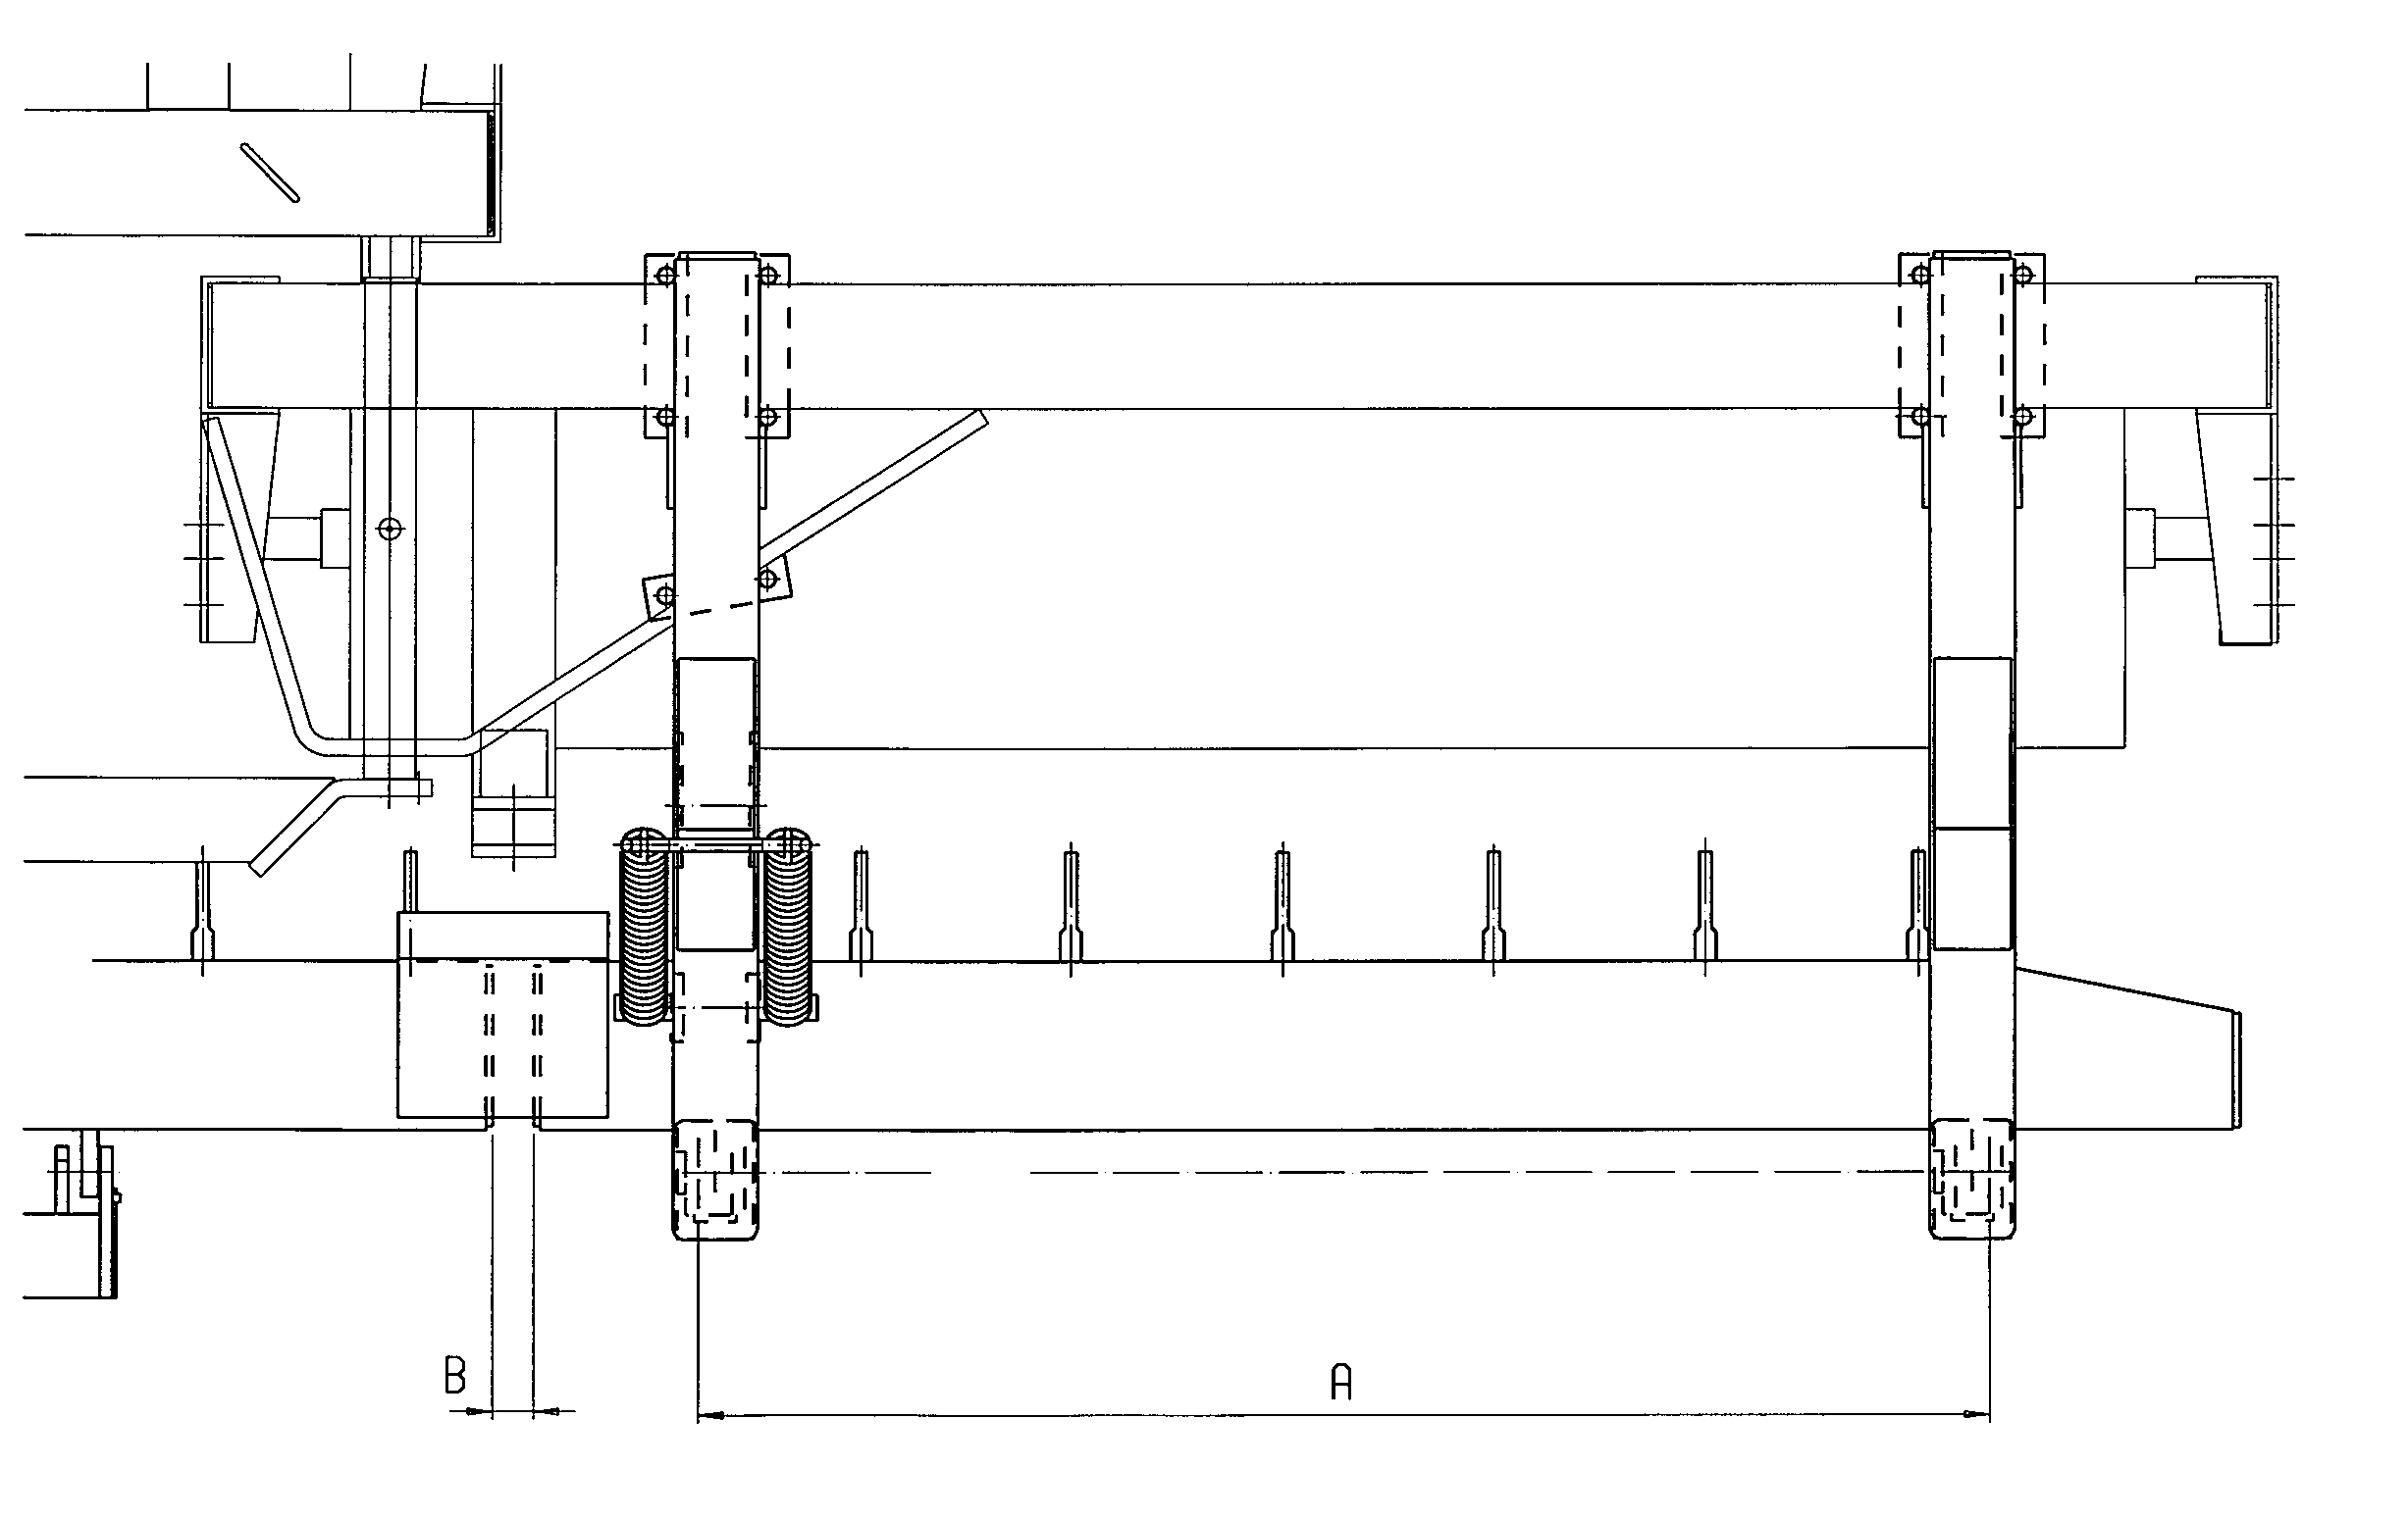

The six holes for suspension of the leveling bars must now be aligned; if they
are not, adjust the suspension of the centre board a little forwards or
backwards. It is important that the roller drawbar should be horizontal.

Mount the middle levelling bar (weight 105 kg) with the pins and suspend it
in the springs.
mount the side bars first (weight 95 kg). Suspend them first in the pins. Then
the rams with hoses at the rear, on the side sections.
Mount the springs first at the bottom. Hook them on the hooks at the top with
the aid of a tube as shown in fig. 9.
Fig. 9:
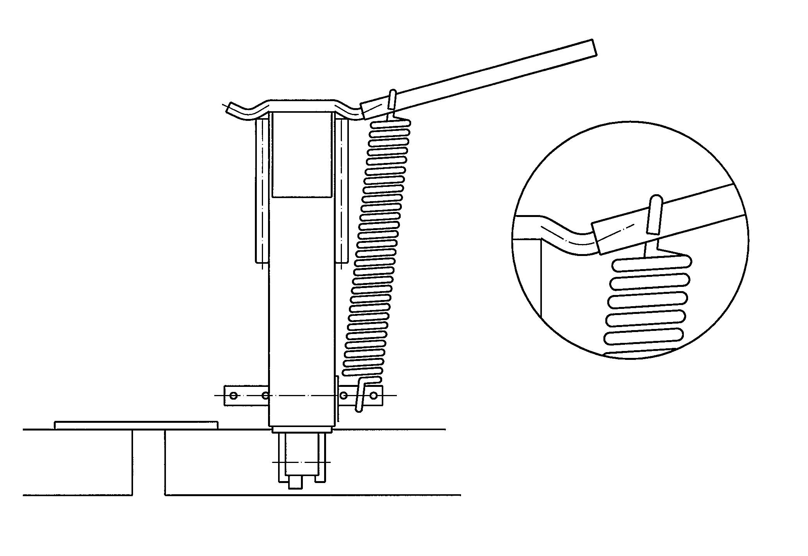

Adjustment:
Check that the distance B between the ends of the levelling bars (fig. 8) is 4-
5 cm. If it is not, the side section-suspensions must be moved. Lastly, tighten
all the nuts fully.

Hydraulics:
See fig. 10. Attach the T-piece (pos. 1) to the front cross tube of the main
frame straight in front of the left-hand longitudinal tube. Run the hoses out to the rams and attach them with the self-tapping screws and hose clamps
(pos.2). Use a 4,4 mm drill to drill the screw holes.
Take the middle hose along the left-hand tube, use clamps pos. 2.
Take it further in a neat arc and fasten it to the drawbar. It ends at the left-
hand connection on the hydraulic block. Attach the connecting hose to the
right-hand connection and bring it, together with the other hoses, to the
tractor.
Fig. 10:
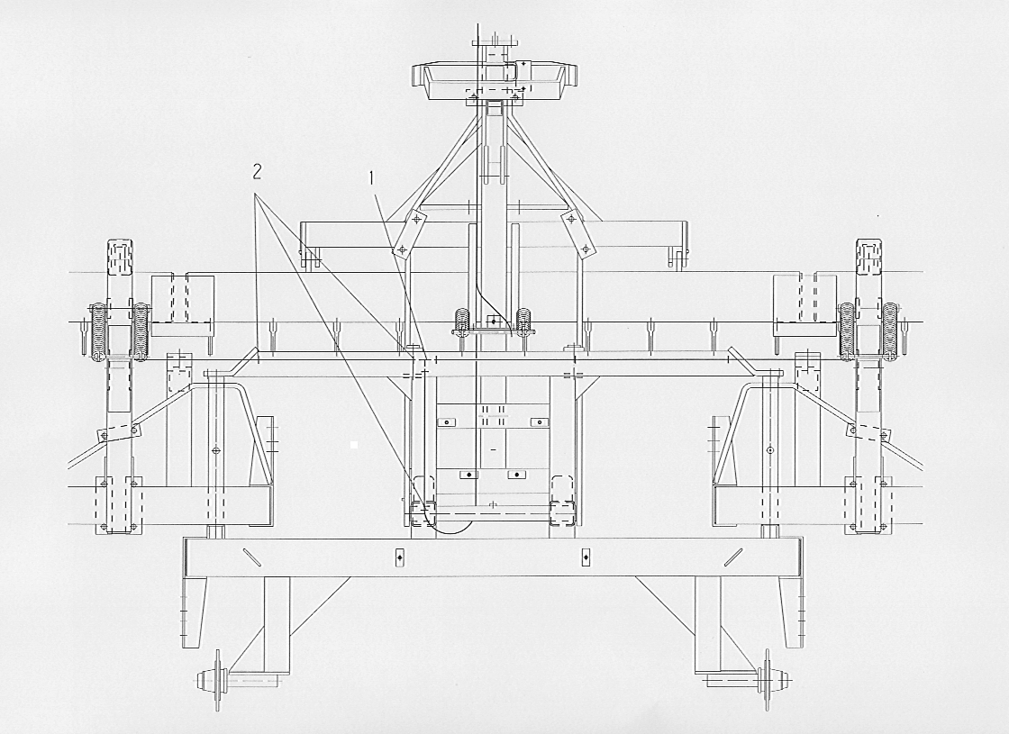

Connection:
Connect the green connecting hoses to a single-acting valve on the tractor.
Two single-acting and one double-acting take-off are normally required
to operate the complete roller with levelling bar. The job can be done with two
double-acting valves, one of which must have a floating setting. If this method
is used, the white and green hoses must be connected to the valve with
the float setting. The green hose must be positioned so that the levelling bar
moves when the operating handle on the tractor is moved towards the float
setting in order to raise the levelling bar without actuating the roller lifting
cylinder.

Testing:
Fold up the roller carefully, ensure that the hoses are not squeezed or stretched
while the roller is being closed up.
With the roller opened out, lower the levelling bar until the ram is fully
extended.
Check that the pressure gauge is registering. With the levelling bar in this
position, it should show the tractor’s maximum pumping pressure. Check
also for loose connections/leaks in the hydraulic system. The gas accumulator
may have worked loose owing to vibration during transport and it must then
be tightened with oil filter pliers or the like.

Operation:
In order to be effective, the levelling bar must always draw a little soil.
Where the soil is heavy, the bar must be pressed down hard. The gauge will
show how hard it is being pressed down. In most instances, a pressure of 40-
50 bar will be appropriate.

Maintenance:
Tighten all the nuts and check for oil leaks after the first day’s operation.
When the tines become worn down about 5 cm, they can be fitted in the
lowest hole.

When the board is not in use, it must be fully raised in order to avoid rust
damage to the piston rods.

Dismantling:
The levelling bar must not normally be dismantled. It should be removed
only for repairs or to be scrapped. Disassemble in the reverse sequence
to assembly.

Scrapping:
Discard hoses, accumulator and oil, to be taken away and destroyed; the rest
can be recycled as scrap.

HYDRAULIC CRACKERBOARD

Like the levelling board the crackerboard is mounted in front of the rollers, where it performs an excellent cultivation of the rough ploughing as well as of already prepared soil.

The crackerboard is particularly well suited to be used on clay soil after ploughing. The vibrating effect of the tines will cut up any left over clods and level the field. When driving in the field the working depth of the crackerboard can be adjusted hydraulically without changing the angle of the tines noticebly.

If you do not want to use the crackerborad the tines can be folded hydraulically to a horizontal position in which you can drive backwards with the roller and drive on grass.

Mounting

The crackerboard is mounted/will be mounted on all Compact 2000 models but only from the factory and by specially trained fitters.

Fig. 11
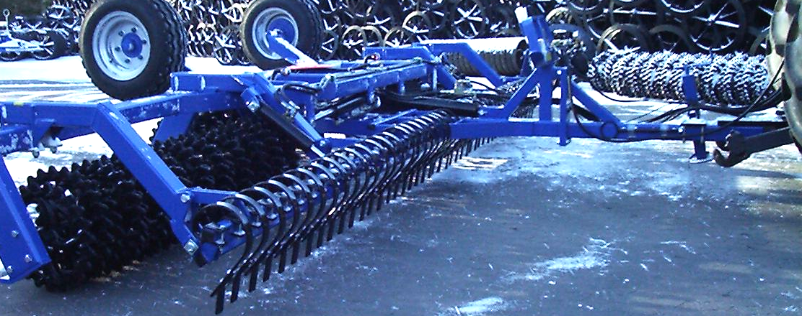

For mounting the Compact 2000 on the tractor see ”Start-up”. The socket on the roller must be level when operating to make sure that the middle section of the crackerboard is working at the same depth as the side sections and that the weight on the roller sections is divided evenly

Hydraulic
A double-action socket on the tractor is needed for operating the crackerboard, marked green. With the addition of the crackerboard the rocker cylinder, marked white, has been changed to a double-action cylinder which is necessary for keeping the crackerbord steady in the soil. Thus three double-action sockets are needed for a Compact which has been fitted with a crackerboard.

Driving and Operating
Compact 2000 is unfolded to operating position like the traditional Compact. There is, however, one difference: Compact 2000 with the crackerboard has been fitted with a double-action rocker cylinder. The roller must be tilted completely towards the adjustable stop and the rocker cylinder should not be put in floating position when a crackerboard has been fitted to Compact 2000.

The crackerboard is a flexible unit with a variety of applications. When adjusted to a working depth of about 5 cm the vibriting tines will crush any clods of earth. Adjusting the crackerboard to a deeper position gives an increased levelling effect, much like a levelling board, as small banks of earth gathers in front of the tines.

The crackerboard is not meant to function as dozer blade but to perform a light tillage of the soil. As each tine moves individually and thus yields to local obstacles, driving with the crackerboard is easy and requires less adjusting than the levelling board when driving.

The crackerboard is divivded into three sections each with its own cylinder. It may happen that the sections sometimes work at differents depths. It may therefore be necessary to ”reset” the sections by tipping up the tines and then unfold the crackerboard to operating position once more. To avoid an uneven adjustment of the crackerboard a pilot controlled check valve has been fitted to the cylinders. This makes it impossible for oil to float from one cylinder to another when the hydraulic handle is not activated. It is thus only when the handle is activated and the valves are open that an unenven wandering of cylinders may occur.

Effect
In total the crackerboard does not require much effect as the distance between the tines allows the soil to pass. The tines move individually and thus yield to local obstacles. The flexibility of the crackerboard is thus a great advantage compared to the levelling board as the entire levelling organ does not have to be released because of one obstacle only.

If the crackerboard is adjusted to a deeper working depth more effect is required as larger amounts of soil is cultivated.

Maintenance
After the first day of use nuts and bolts should be tightened. Please check that the hydraulic system does not have any leaks.

Lubrication
To protect and increase the life span of the crackerboard lubrication points have been added where the load is highest.

- 3 lubrication points in cylinder eyes (daily lubrication).
- 6 lubrication points in bolts for bushings in the crackerboard (daily lubrication).

Lubrication is most easily done when the tines on the crackerboard is folded.

Wear parts
The wear parts have been fitted in the top holes on the tines from the factory. The wear parts should be moved to the bottom holes before the tines begins to wear down. When the wear parts, positioned in the bottom holes, has worn down they should be changed. Wear parts should be changed with the crackerboard somewhat unfolded.

Fig. 12
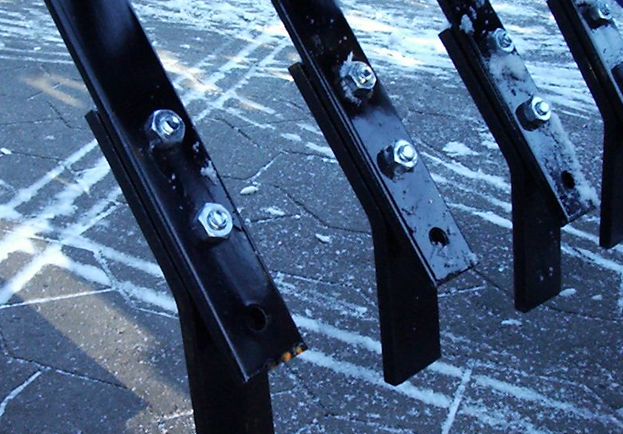

Repairs
Changing cylinders for the crackerboard
Repairs should be done with the sidesections of the roller unfolded and the crackerboard somewhat unfolded allowing the tines to rest on the ground. Please remeber to ease the pressure on the cylinder before the hydraulic hoses are loosened.

- Remove the hoses (To avoid soiling the ground during repair place a tray underneath to collect the oil).
- Remove split pins and rivets. The cylinder is now free to be removed.
- Mount the new cylinder in reverse order to the above. Please remeber to secure that the rivet is in mesh with the rivet stop and secure the rivets with split pins.

After mounting activate the hydraulic handle to the depth control and unfold and fold the tines a couple of times to air the system.

Changing the seals
For removing the cylinder please see 1. and 2. under ”Changing cylinders for the crackerboard”.
Fig. 13
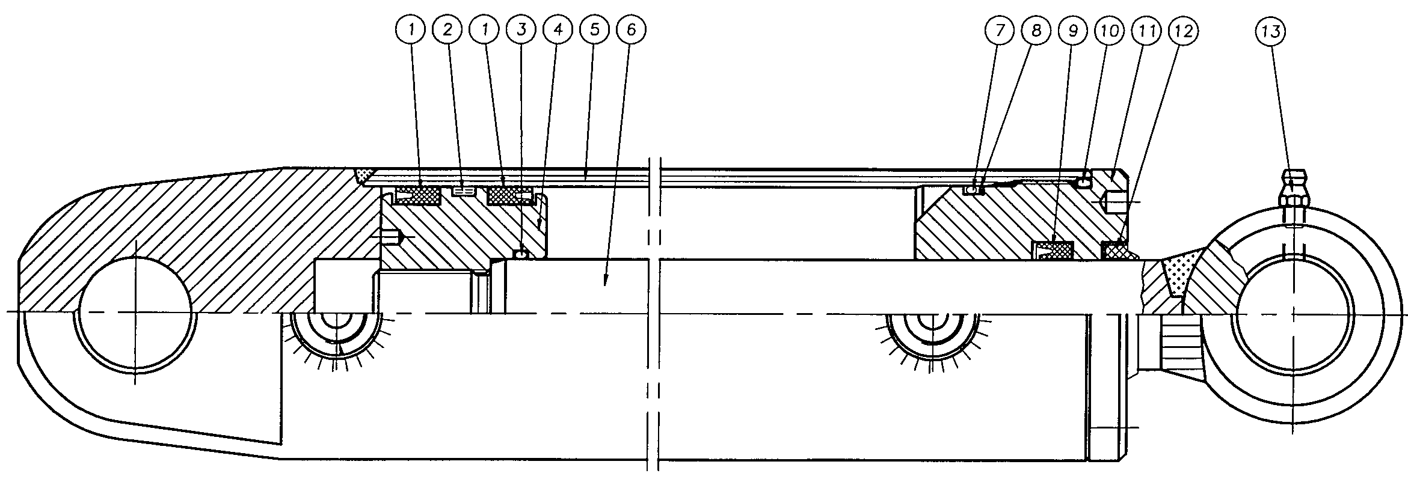

- Empty the cylinder for oil by moving the piston rod back and forth.
- Slide the piston rod into the middle position and then loosen the toppiece (pos. 11) about 25 mm. (Speciel tools are required for removing the top piece. If the top piece is stuck try heating up the front part of the socket. When the top pieces has been loosened 25 mm. pull out the piston rod towards the top piece and the top piece can be removed. Then remove the piston rod (pos. 6) from the cylinder tube (pos. 5).
- Remove the locking nut at the end of the piston rod.
- Pull the sleeve shoe (pos. 4) of the piston rod.
- Pull the top piece (pos. 11) of the piston rod.
- Remove all seals in the top piece and sleeve shoe (pos. 1+2+3+7+8+9+10+12)
- Clean all parts and check for cuttings, burrs etc. Check for corrosion around the scraber rings (pos. 12) in the top piece. If corrosion is found it should be removed.

Mounting
- Mount the new seals in the top piece and the sleeve shoe.
- Lubricate the thread of the top piece (pos. 11) and the cylinder tube with grease or corrosion-preventive anti seizure agent.
- Mount the top piece (pos. 11) on the piston rod.
- Mount the sleeve shoe (pos. 4) and screw on the lock nut. Lock it with Loctite. Please make sure that the thread is completely cleen and free of oil or other impurities before using Loctite. Do not fill with oil until 12 hours after using Loctite.
- Lubricate the sleeve (pos. 4) on the sleeve shoe and th einside of the cylinder tube and slide the piston rod back into the middle position.
- Mount the top piece and fasten it.
- Mount the cylinder. Please make sure that the rivet is in mesh with the rivet stop and secure the rivets with split pins.
- Mount the hoses. Please make sure that the hoses are not squeezed and that all connections are tight.

SPARE PARTS:

